Adverbs

Place:
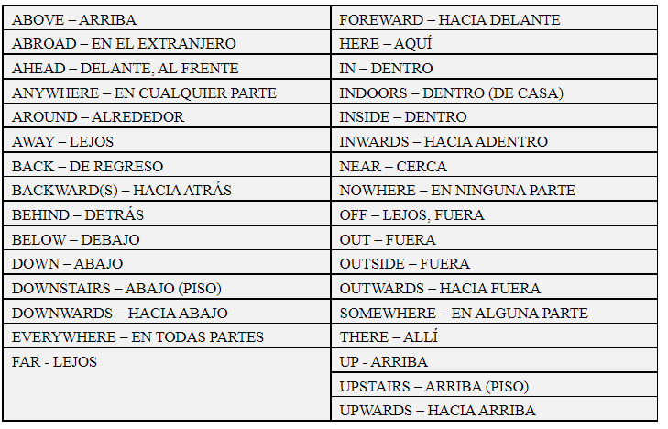

Time:
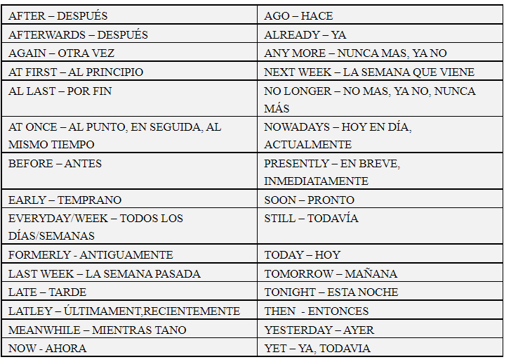
Lately: ultimamente

Frequency:
*Ocasionally
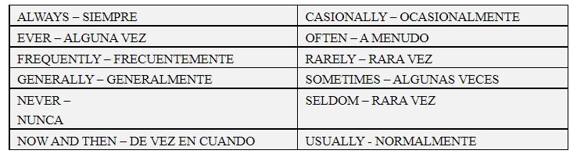

Mode: *distinctly
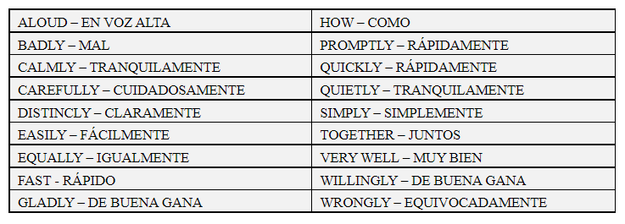

Quantity:
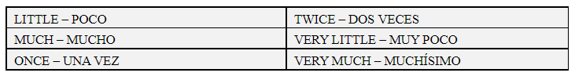

Probability:

Afirmattive:
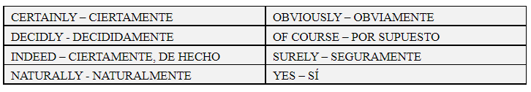

Negative:
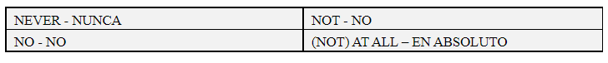

- I never go to the dentist.
- I have never visited the church.
- Do you always go to WayCo?
- I brush my teeth everyday.
- Everyday I brush my teeth.

